

NAME: BISMA FATIMA
CLASS: CS A
ROLL NO: F24605036
COURSE: ARTIFICIAL INTELLIGENCE
COURSE CODE: CS-281
LECTURER: SIR IJLAL HAIDER

LAB 02

In Lab Tasks
Task 1
Write a Python program to extract all odd numbers from a given list of integers. Use list comprehension to achieve this and print the result. For example, given the list [1, 2, 3, 4, 5, 6, 7, 8, 9, 10], the output should be [1, 3, 5, 7, 9].
PROGRAM
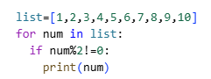
OUTPUT
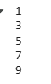
Task 2
Create a numpy array of size 5-by-5 containing all random values. Determine the transpose and inverse of this matrix.
PROGRAM
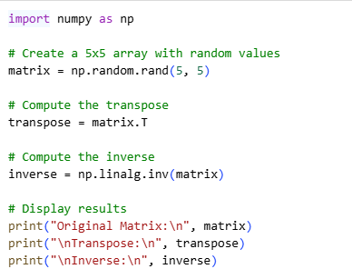
OUTPUT
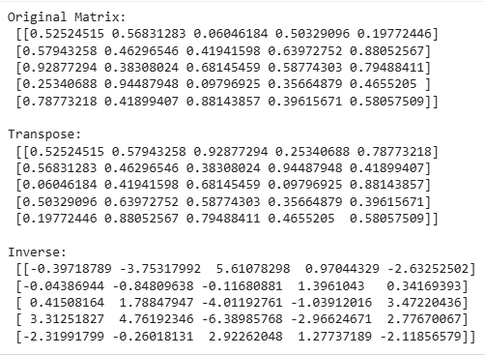
Task 3
Write a Python program to create a pandas DataFrame from a dictionary containing data for countries, their capitals, and populations. The keys of the dictionary should represent the columns: 'Country', 'Capital', and 'Population'. The values should be lists representing the data for each column.
PROGRAM
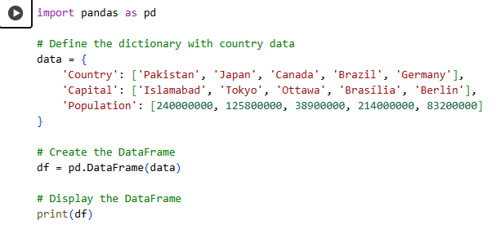
OUTPUT
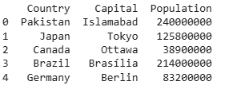
Task 4
Create a bar chart showing the sales of different fruits. Use the following data:
- Fruits: ['Apples', 'Bananas', 'Cherries']
- Sales: [150, 200, 100]

PROGRAM
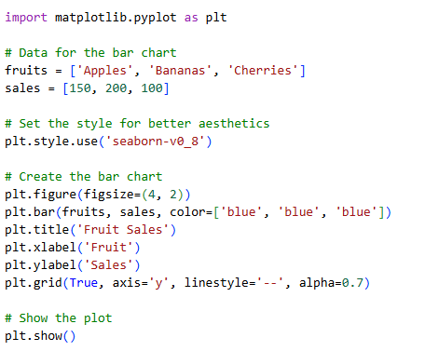
OUTPUT
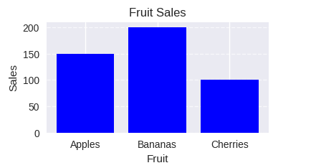

Post Lab Tasks
Task 1
Write a Python program using NumPy to count the number of non-zero values in a given NumPy array.
PROGRAM
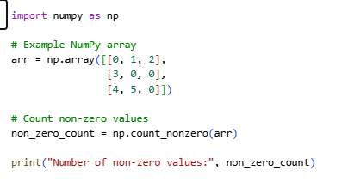
OUTPUT
Task 2
Write a Python program using NumPy to create a 4x5 array, then find and print its transpose. The transpose should swap the rows and columns of the original array.

PROGRAM
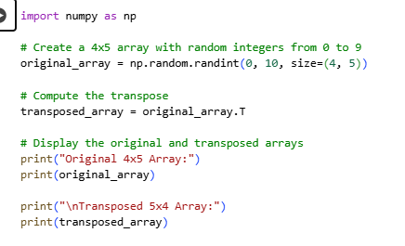
OUTPUT
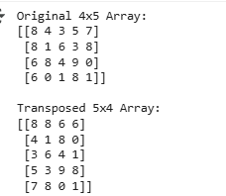
Task 3
Write a Python program to create a pandas DataFrame from a dictionary containing the following data:
- Name: ['Alice', 'Bob', 'Charlie']
- Age: [25, 30, 35]
- City: ['New York', 'Los Angeles', 'Chicago']

PROGRAM
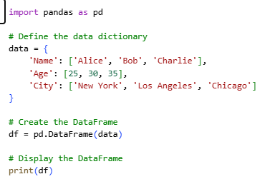
OUTPUT
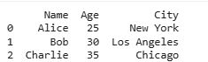
Task 4
Plot a scatter diagram to show the disadvantages of smoking with increasing age and weight.
The age vector: [10, 20, 30, 40, 50]
The weight vector: [35, 45, 55, 65, 75]
PROGRAM
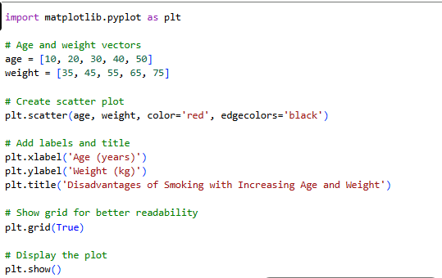
OUTPUT
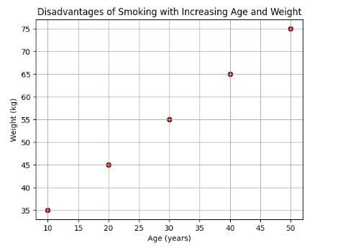
Task 5
Given the 1D NumPy array arr = np.array([10, 20, 30, 40, 50, 60]), reshape it into a 2D array with 2 rows and 3 columns. What will the resulting array look like?
PROGRAM
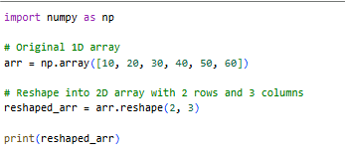
OUTPUT
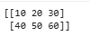
Task 6
Given a NumPy array arr = np.array([1, 2, 3, 4, 5, 6, 7, 8]), can you reshape it into a 3D array with dimensions (2, 2, 2)? Write the code and check if the reshaping is successful. What error (if any) would you encounter?
PROGRAM
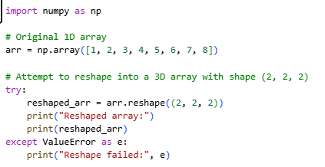
OUTPUT
